Logical Volume Management (LVM)Pending
Tasks
1.Create two 200MB partitions using fdisk or parted, then use the lsblk command to verify their creation.
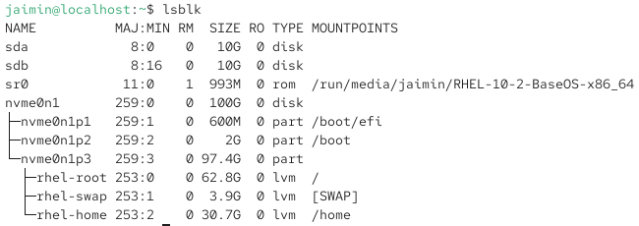
lsblk

2.Initialize both partitions as physical volumes using the pvcreate command and confirm their status with pvs.
pvs
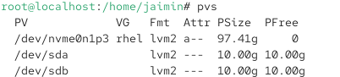

3.Create a new volume group named musicvg using the two physical volumes, then display its details with vgdisplay.

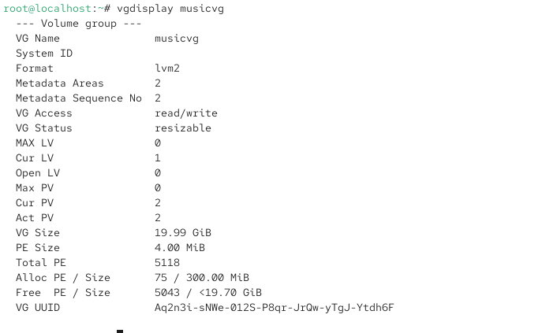
4.Create a logical volume called playlistlv of size 300MB inside musicvg, format it with ext4, and mount it to /mnt/playlist.

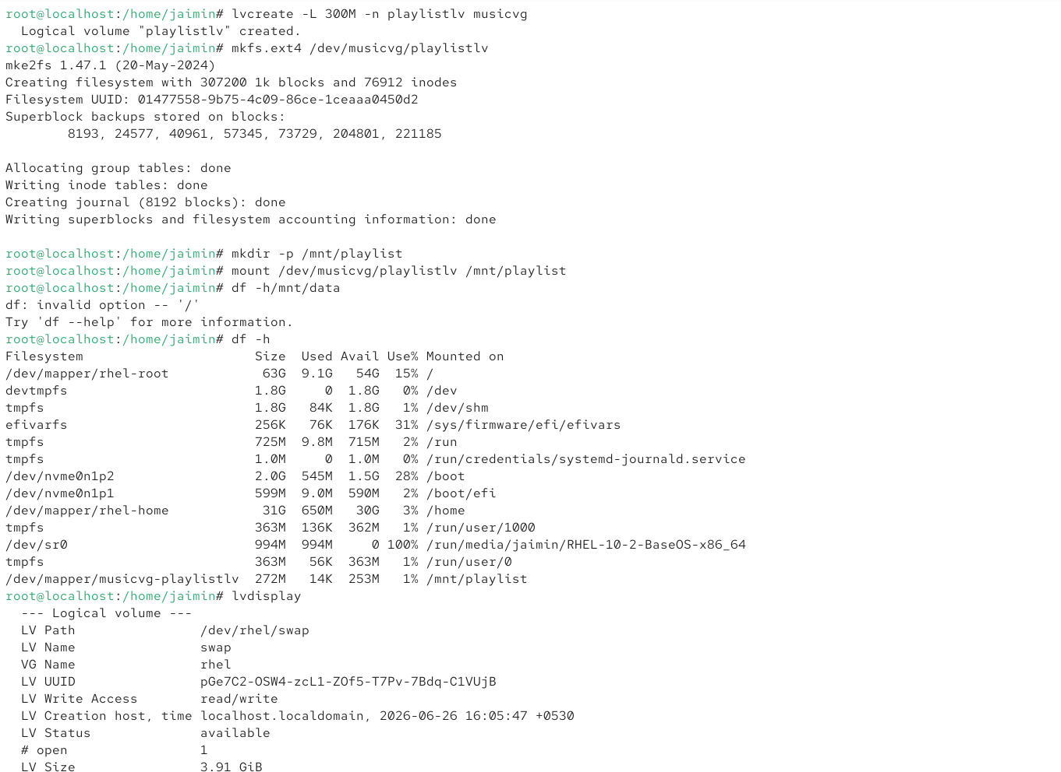
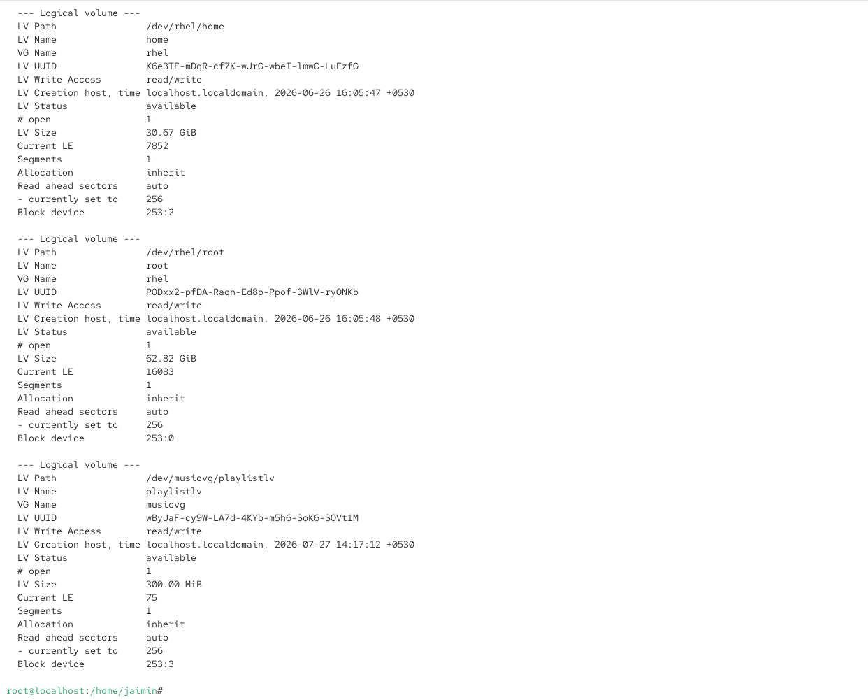
5.Resize playlistlv by adding 50MB more space using lvextend, then expand the filesystem and show the updated size with df -h.Hint: Use resize2fs after lvextend to update the filesystem size.

